UNIVERSITY OF ILLINOIS
NAVAL RESERVE OFFICERS TRAINING CORPS

NEW STUDENT ORIENTATION
WELCOME PACKET
SUMMER 2023

UNIVERSITY OF ILLINOIS NROTC
236C ARMORY BUILDING
505 EAST ARMORY AVE
CHAMPAIGN, IL 61820

NAME____________________________

Mission of the NROTC

The mission of the NROTC is to develop midshipmen mentally, morally and physically and to imbue them with the highest ideals of duty and loyalty, and with the core values of honor, courage, and commitment in order to commission college graduates as naval officers who possess a basic professional background, are motivated toward careers in the naval service, and have a potential for future development in mind and character so as to assume the highest responsibilities of command, citizenship and government.

Mission of the U.S. Navy

The mission of the Navy is to maintain, train and equip combat-ready naval forces capable of winning wars, deterring aggression, and maintaining freedom of the seas.

Mission of the U.S. Marine Corps

To provide Fleet Marine Forces with combined arms and supporting air component for service with the United States Fleet in the seizure and defense of advanced naval bases and for the conduct of such land operations as may be essential to the prosecution of the naval campaign.

The Sailors' Creed

I am a United States Sailor. I will support and defend the Constitution of the United
States of America and I will obey the orders of those appointed over me. I represent the
fighting spirit of the Navy and those who have gone before me to defend freedom and
democracy around the world. I proudly serve my country's Navy combat team with
Honor, Courage and Commitment. I am committed to excellence and the fair treatment
of all.

Important Dates

Birth date of the Navy: 13 OCTOBER 1775
Birth date of the Marine Corps: 10 NOVEMBER 1775
Birthplace of the Marine Corps: Tun Tavern, Philadelphia

Navy/Marine Corps Colors

Official Colors of the Navy: Blue and Gold
Official Colors of the Marine Corps: Scarlet and Gold

The Honor Code

A Midshipman does not lie, cheat, or steal.

United States Navy and Marine Corps Core Values

Honor, Courage, and Commitment

Eleven General Orders for a Sentry on Post

- To take charge of this post and all government property in view.

- To walk my post in a military manner, keeping always on the alert and observing everything that takes place within sight or hearing.

- To report all violations of orders I am instructed to enforce.

- To repeat all calls from posts more distant from the guardhouse than my own.

- To quit my post only when properly relieved.

- To receive, obey and pass on to the sentry who relieves me all orders from the commanding officer, officer of the day and officers and noncommissioned officers of the guard only.

- To talk to no one except in the line of duty.

- To give the alarm in case of fire or disorder.

- To call the corporal of the guard in any case not covered by instructions.

- To salute all officers and all colors and standards not cased.

- To be especially watchful at night, and during the time for challenging, to challenge all persons on or near my post and to allow no one to pass without proper authority.

Watchstanding Principles

1. Procedural compliance 4. Formality

2. Questioning attitude 5. Level of knowledge

3. Forceful backup 6. Integrity

Important People

President and Commander in Chief: Honorable Mr.______________________
Vice President: Honorable Mrs._____________________
Secretary of State: Honorable Mr.______________________
Secretary of Defense: Honorable Mr.______________________
Secretary of the Navy: Honorable Mr.______________________
Chairman of the Joint Chiefs of Staff: __________________________________
Vice-Chairman of the JCS: __________________________________
Chief of Naval Operations: __________________________________
Commandant of the Marine Corps: __________________________________
Chief of Staff of the Army: __________________________________
Chief of Staff of the Air Force: __________________________________
Sergeant Major of the Marine Corps: __________________________________
Master Chief of the Navy: __________________________________

Commander, Naval Education and Training Command: ____________________________
Commander, Naval Service Training Command: __________________________________
Professor of Naval Science (U of I): ____________________________________________
NSO, CO:_________________________________________________________________
NSO, XO:_________________________________________________________________
NSO, Company 1st Sgt :______________________________________________________

Leadership Traits Leadership Principles

- Bearing 1. Be technically and tactically proficient.
- Courage 2. Know yourself and seek self-improvement.
- Decisiveness 3. Know your Sailors/Marines and look out for their
- Dependability welfare.
- Endurance 4. Keep your Sailors/Marines informed.
- Enthusiasm 5. Set the example.
- Initiative 6. Ensure the assigned task is understood, supervised and
- Integrity accomplished.
- Judgment 7. Train your Sailors/Marines as a team.
- Justice 8. Make sound and timely decisions.
- Knowledge 9. Develop a sense of responsibility among your
- Loyalty subordinates.
- Tact 10. Employ your command in accordance with its
- Unselfishness capabilities.
11. Seek responsibility and take responsibility for your actions.

Code of Conduct for Members of the Armed Forces
- I am an American, fighting in the forces which guard my country and our way of life. I am prepared to give my life in their defense.

- I will never surrender of my own free will. If in command, I will never surrender the members of my command while they still have the means to resist.

- If I am captured, I will continue to resist by all means available. I will make every effort to escape and aid others to escape. I will accept neither parole nor special favors from the enemy.

- If I become a prisoner of war, I will keep faith with my fellow prisoners. I will give no information or take part in any action which might be harmful to my comrades. If I am senior, I will take command. If not, I will obey the lawful orders of those appointed over me and will back them up in every way.

- When questioned, should I become a prisoner of war, I am required to give name, rank, social security number, and date of birth. I will evade answering further questions to the utmost of my ability. I will make no oral or written statements disloyal to my country and its allies or harmful to their cause.

- I will never forget that I am an American, responsible for my actions, and dedicated to the principles which made my country free. I will trust in my God and in the United States of America.
Range Knowledge
I. Safety Rules

- Treat every weapon as if it were loaded

- Never point a weapon at anything you do not intend to shoot.

- Keep finger straight and off the trigger until you are ready to fire

- Keep the weapon on “safe” until you intend to fire.

II. Weapon Conditions

Condition 1. Magazine inserted, round in chamber, slide forward, and safety on.

Condition 2. Not applicable with the M-16.

Condition 3. Magazine inserted, chamber empty, slide forward, and safety lever on.

Condition 4. Magazine removed, chamber empty, slide forward, and safety lever on.
US Navy and Marine Corps Service Songs

Anchors Aweigh

Stand, Navy, out to sea, Fight our battle cry;
We’ll never change our course, So vicious foe steer shy-y-y-y
Roll out the TNT, Anchors Aweigh. Sail on to victory
And sink their bones to Davy Jones, hooray!

Anchors Aweigh, my boys, Anchors Aweigh.
Farewell to foreign shores, we sail at break of day-ay-ay-ay.
Through our last night on shore, drink to the foam,
Until we meet once more. Here’s wishing you a happy voyage home.

Blue of the mighty deep, Gold of God's great sun.
Let these our colors be, Till all of time be done, done, done, done.
On seven seas we learn Navy's stern call:
Faith, courage, service true, With honor, over honor, over all.

Marines’ Hymn

From the halls of Montezuma, to the shores of Tripoli,
We fight our country’s battles in the air, on land and sea.
First to fight for right and freedom, and to keep our honor clean,
We are proud to claim the title of United States Marines.

Our flag’s unfurled to every breeze from dawn to setting sun.
We have fought in every clime and place, where we could take a gun.
In the snow of far off northern lands and in sunny tropic scenes,
You will find us always on the job, The United States Marines.

Here’s health to you and to our Corps which we are proud to serve.
In many a strife we’ve fought for life and never lost our nerve.
If the Army and the Navy ever look on heaven’s scenes,
they will find the streets are guarded by United States Marines!

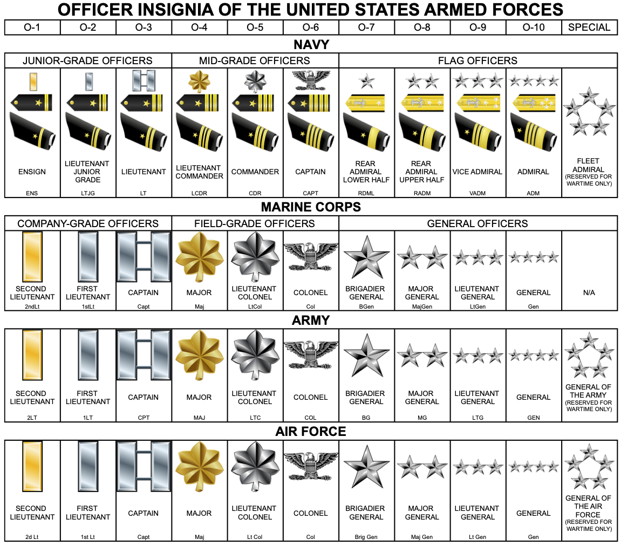
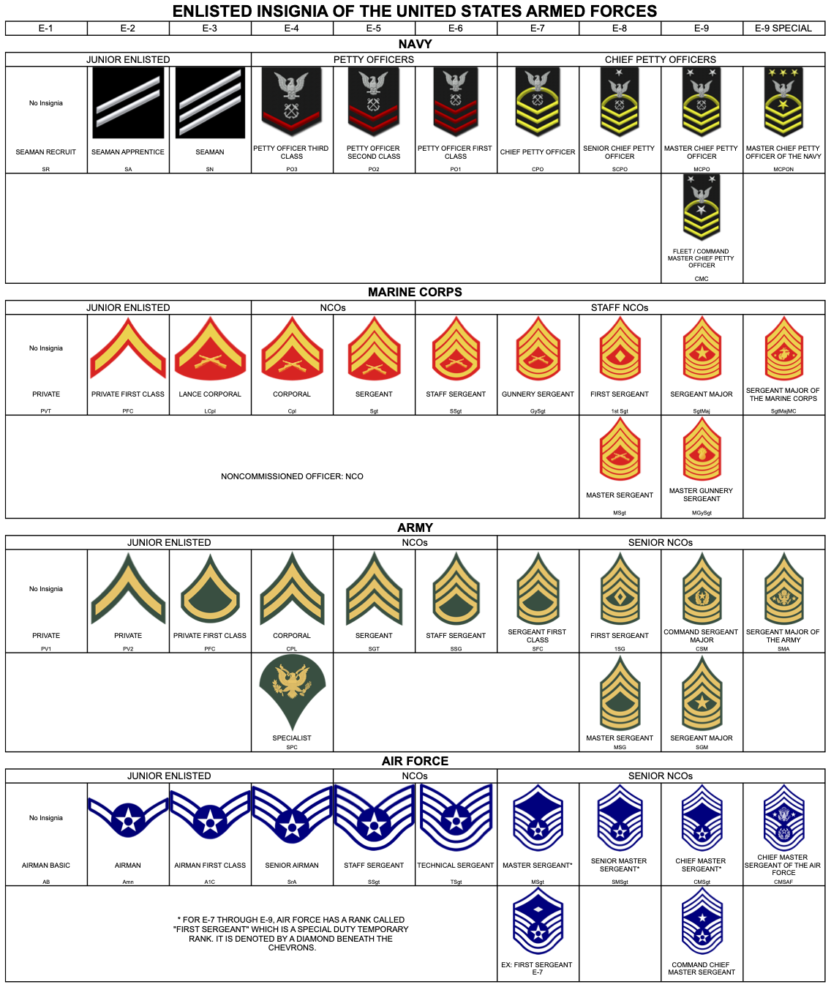

Nautical Terms

CIVILIAN | NAUTICAL
FLOOR | DECK
CEILING | OVERHEAD
WALL | BULKHEAD
WINDOW | PORTHOLE
DOOR | HATCH
HALLWAY | PASSAGEWAY
STAIRS | LADDERWELL
UPSTAIRS | TOPSIDE
DOWNSTAIRS | BELOW
LEFT | PORT
RIGHT | STARBOARD
FRONT | BOW
REAR | STERN
BED/BUNK | RACK
RESTROOM | HEAD
HYGIENE | BASIC DAILY ROUTINE (BDR)
WORKING OUT | PHYSICAL TRAINING (PT)
PHYSICAL TEST | PHYSICAL READINESS TEST (PRT – NAVY)  PHYSICAL FITNESS TEST (PFT – MARINES)
CAFETERIA | CHOW HALL
FOUNTAIN/RUMOR | SCUTTLEBUTT
BAD INFORMATION | BUMSCOOP
MILITARY JAIL | BRIG
RESPONDING TO AN ORDER | AYE, AYE SIR. USED WHEN RESPONDING TO AN ORDER: I UNDERSTAND AND I WILL OBEY
TO CLEAR A SPACE | GANGWAY: TO CLEAR A PATH FOR AN OFFICER ASHORE/AFLOAT
READY TO MOVE/AGREE | GOOD TO GO
MEET | MUSTER
ABSENT | UNAUTHORIZED ABSENCE (UA)
CANCEL THAT ORDER | BELAY THAT COMMAND
CORRECT YOURSELF | AS YOU WERE
CLEAN A SPACE | FIELD DAY
INSPECT THE GROUND | POLICE LINE
LOCK A SPACE | SECURE
LOOK GOOD | SQUARE AWAY
SMART/FAST | HIGH SPEED
CIVILIAN ATTIRE | CIVIES
SHIRT | BLOUSE
PANTS | TROUSERS
HAT | COVER
UNDERWEAR | SKIVVIES
TENNIS SHOES | GO-FASTERS
BELT ALLIGNMENT WITH TROUSERS AND BLOUSE | GIG LINE
PEN | INK STICK
JOB | MOS (MARINES)  RATE (NAVY)
OFFICER | COMMISSIONED OFFICER
SENIOR ENLISTED | NON-COMMISSIONED OFFICER
TIME-OFF | LIBERTY
VACATION TIME | LEAVE

Phonetic Alphabet

A | ALPHA | N | NOVEMBER
B | BRAVO | O | OSCAR
C | CHARLIE | P | PAPA
D | DELTA | Q | QUEBEC
E | ECHO | R | ROMEO
F | FOXTROT | S | SIERRA
G | GOLF | T | TANGO
H | HOTEL | U | UNIFORM
I | INDIA | V | VICTOR
J | JULIET | W | WHISKEY
K | KILO | X | X-RAY
L | LIMA | Y | YANKEE
M | MIKE | Z | ZULU

24-Hour Time

1:00 AM | 0100 | 1:00 PM | 1300
2:00 AM | 0200 | 2:00 PM | 1400
3:00 AM | 0300 | 3:00 PM | 1500
4:00 AM | 0400 | 4:00 PM | 1600
5:00 AM | 0500 | 5:00 PM | 1700
6:00 AM | 0600 | 6:00 PM | 1800
7:00 AM | 0700 | 7:00 PM | 1900
8:00 AM | 0800 | 8:00 PM | 2000
9:00 AM | 0900 | 9:00 PM | 2100
10:00 AM | 1000 | 10:00 PM | 2200
11:00 AM | 1100 | 11:00 PM | 2300
12:00 AM | 1200 | 12:00 PM | 0000

END OF KNOWLEDGE PACKET

History of the ROTC at UIUC

ROTC had its beginnings in the early 1800's when civilian colleges began to offer military instruction to students. During the early stages of the Civil War, it became apparent that the United States Military Academy at West Point, New York was not capable of producing the quantity of loyal officers required to lead the massive and poorly trained volunteer forces fighting in this War. To fill the need for a ready pool of military leaders, Congress included a special provision of the Morrill Land Grant Act of 1862. The Act offered to each state tracts of federally controlled land, or money in lieu of land. States were to sell the land, invest the income, and create and maintain colleges with the proceeds. The colleges were to offer training in agriculture, mechanical arts, and military tactics. In 1916 with World War I raging in Europe, Congress passed the National Defense Act, which created the Reserve Officers Training Corps (ROTC). This Act provided support for college military training and training camps. In 1964, the ROTC Revitalization Act added flexibility and incentives to the program. This Act created the 2-year ROTC program, increased pay, and created new scholarships. This Act also changed ROTC from mandatory to optional training on campuses across the Nation. In 1973, women became eligible for enrollment in ROTC.

On the first day of classes, Spring Semester 1868, students at the Illinois Industrial University, currently named the University of Illinois, were formed into ranks before an instructor. These 75 young men, each of whom had to be at least 15 years of age, reported for roll call to the Military Department. The first campus dress code required all pupils to wear a gray uniform with a blue cap. From this beginning, training in Military Tactics was to be an integral part of education at the University of Illinois.

The present Armory building was built in 1914 with the last major renovation in 1926. The Armory building was constructed exclusively for military training: specifically to house equipment, and provide offices, classrooms and a drill floor. The original Armory floor was dirt and cinders. In 1919, ROTC, which had been created by the National Defense Act of 1916, began full operations on campus. All able-bodied males were required to take at least basic military training in ROTC. The University of Illinois established Naval ROTC in 1945 and Air Force ROTC in 1949. This made it one of the few Universities in the Nation with tri-service ROTC, which still holds true today.

Illinois has such a rich tradition of commissioning the best and brightest naval officers that when the construction of the U.S.S. Illinois battleship was halted after the end of World War II the bell which was cast for the U.S.S. Illinois battleship was sent to the University of Illinois NROTC while the rest of the ship was scrapped. Midshipmen of NROTC are in charge of ringing the bell when the visiting team kicks to Illinois, and for each point the Illini score.

Honorable WGNB Graduates That Have Given the Ultimate Sacrifice

LCDR John Gary Griffith USN (10JAN1926 - 12MAR1968)
John Gary Griffith earned a degree from the College of Fine and Applied Arts at the University of Illinois in 1959. Lieutenant Commander Griffith was killed in a crash of a Naval A-6A Intruder in the Gulf of Tonkin during a night mission over Vietnam. His awards include the Navy Cross and Silver Star for successful night air strikes over Vietnam.

Capt Reid B. Nannen USMC (15OCT1981 - 01MAR2014)
Reid B. Nannen grew up in Hopedale, IL. He enrolled in the University of Illinois College of Liberal Arts and Sciences and received his bachelor’s degree in History in 2004. He died 01MAR14 from fatal injuries sustained in a F/A-18C Hornet crash on the Fallon Range Training Complex. Capt Nannen was on temporary duty to the Naval Strike and Air Warfare Center in Fallon, Nevada, as a Top Gun student.

CDR Orlando A. Suarez USN (14DEC1958 - 15MAR2004)
Orlando Suarez was born in Cuba and became a naturalized American citizen after he and his mother escaped into the United States. He enlisted in the Navy serving as a Hospital Corpsman until he was selected for the Enlisted Commissioning Program in 1986. He received a degree in Mathematics and commissioned as a Submarine Warfare Officer in 1989. CDR Suarez died of injuries sustained from a cycling accident while training for a marathon.

Capt Anthony Y. Slick USMC (03SEPT1967 - 07MAR1996)
Anthony Slick was born in Freeport, IL. He received a degree in Electrical Engineering in 1990 and commissioned as a Second Lieutenant. Capt Slick’s awards include the Air Strike Flight Medal and the Navy/Marine Corps Achievement Medal. He and his pilot were killed when their F/A-18 disappeared during a training mission off the coast of South Carolina.

2ndLt David W. Skibbe USMC (22OCT1946 - 02MAR1970)
David Skibbe grew up in Des Plaines, IL before graduating from the University of Illinois in the College of Agriculture, Consumer, and Environmental Sciences in 1969. Lt Skibbe was leading a reconnaissance team in the Quang Nam Province, South Vietnam, when they engaged in a firefight with enemy forces. An emergency medical helicopter arrived in the recovery area to evacuate the Marines who were injured, including Lt Skibbe. He was killed when the hoist cable broke while he was being drawn into the helicopter.

LT James M. Albright USN (13APR1936 - 10MAR1967)
James Albright grew up in Des Plaines, IL before enrolling at the University of Illinois in the College of Commerce and Business Administration. He commissioned as an Ensign in the Navy in 1959. LT Albright died in the crash of a Navy transport plane near Ninh Thuan, South Vietnam in which 24 other servicemen were killed. The plane was shot down by enemy gunfire.

1stLt William S. Sommerhof USMC (13JAN1958 - 23OCT1983)
William Sommerhof grew up in Springfield, IL before graduating from the College of Liberal Arts and Sciences in 1980. Lt Sommerhof was killed in Beirut, Lebanon when a large Islamic truck loaded with 2,500 pounds of TNT crashed through the main gate of the U.S. Marine Headquarters killing 241 U.S. Army, Marine, and Navy service men and wounding 81.

NOTES
____________________________________________________________________________________________________________________________________________________________
____________________________________________________________________________________________________________________________________________________________________________________________________________________________________________________________________________________________________________________________________________________________________________________________________________________________________________________________________________________________________________________________________________________________________________________________________________________________________________________________________________________________________________________________________________________________________________________________________________________________________________________________________________________________________________________________________________________________________________________________________________________________________________________________________________________________________________________________________________________________________________________________________________________________________________
NOTES
____________________________________________________________________________________________________________________________________________________________________________________________________________________________________________________________________________________________________________________________________________________________________________
____________________________________________________________________________________________________________________________________________________________________________________________________________________________________________________________________________________________________________________________________________________________________________________________________________________________________________________________________________________
________________________________________________________________________________________________________________________________________________________________________________________________________________________________________________________________________________________________________________________________________________________________________________________________________________________________________________________________________________________________________________________________________
NOTES
____________________________________________________________________________________________________________________________________________________________________________________________________________________________________________________________________________________________________________________________________________________________________________
____________________________________________________________________________________________________________________________________________________________________________________________________________________________________________________________________________________________________________________________________________________________________________________________________________________________________________________________________________________
________________________________________________________________________________________________________________________________________________________________________________________________________________________________________________________________________________________________________________________________________________________________________________________________________________________________________________________________________________________________________________________________________
NOTES
____________________________________________________________________________________________________________________________________________________________________________________________________________________________________________________________________________________________________________________________________________________________________________
____________________________________________________________________________________________________________________________________________________________________________________________________________________________________________________________________________________________________________________________________________________________________________________________________________________________________________________________________________________
________________________________________________________________________________________________________________________________________________________________________________________________________________________________________________________________________________________________________________________________________________________________________________________________________________________________________________________________________________________________________________________________________
NOTES
____________________________________________________________________________________________________________________________________________________________________________________________________________________________________________________________________________________________________________________________________________________________________________
____________________________________________________________________________________________________________________________________________________________________________________________________________________________________________________________________________________________________________________________________________________________________________________________________________________________________________________________________________________
________________________________________________________________________________________________________________________________________________________________________________________________________________________________________________________________________________________________________________________________________________________________________________________________________________________________________________________________________________________________________________________________________
NOTES
____________________________________________________________________________________________________________________________________________________________________________________________________________________________________________________________________________________________________________________________________________________________________________
____________________________________________________________________________________________________________________________________________________________________________________________________________________________________________________________________________________________________________________________________________________________________________________________________________________________________________________________________________________
________________________________________________________________________________________________________________________________________________________________________________________________________________________________________________________________________________________________________________________________________________________________________________________________________________________________________________________________________________________________________________________________________

